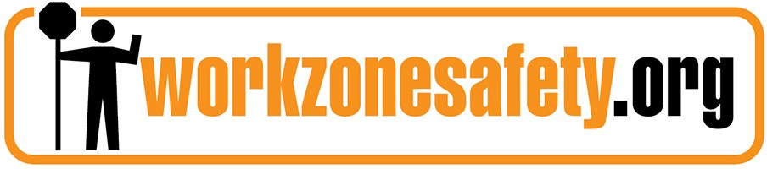

National Work Zone Management Conference
September 11-13, 2018
Herndon, Va.

SPONSORSHIPS & BENEFITS

Gold: $5,000

- Reserved exhibit space for outdoor product demonstration.
- Lead recognition in event program, and on conference app and website.
- Indoor table top exhibit space.
- Lead recognition and reserved table for first-day networking lunch.
- Access to contact information for registered attendees.
- Corporate logo projected on screen during general sessions.
- Opportunity for distribution of marketing materials at registration.
- 2 complimentary registrations.

Silver $3,500

- Recognition in event program, and on conference app and website.
- Indoor table top exhibit space.
- Recognition as buffet lunch sponsor.
- Opportunity for distribution of marketing materials at registration.
- 1 complimentary registration.

Hotel Information

Crowne Plaza Dulles Airport
2200 Centreville Road
Herndon, VA 20170
Phone: (703) 471-6700

Group Name for Discount Room Rate: National Traffic Management and Work Zone.
Rooms Cut-off Date: 8/13/18
Discounted Room Rate: $149 per night

250 E Street S.W., Suite 900
Washington, D.C. 20024
T: 202.289.4434 www.artba.org

2018 National Work Zone Management Conference
(Sept. 11-13, 2018 | Herndon, VA)

SPONSORSHIP FORM

Type of Sponsorship

□ Gold ($5,000)
□ Silver ($3,500)
Primary Contact: Title: Company Name: Address:
Phone: Fax: Email: RICKY.STONE@VER-MAC.COM
Method of payment: □ Bill my company □ Credit Card
CreditCard#:________________________________________________________ Exp. Date: Name on card:

To become a sponsor, please email this form to ARTBA’s Peter Embrey at pembrey@artba.org

